**Exp 8: Reproducing an Image Using Prompts for Image Generation**

**Aim:**

To demonstrate the ability of text-to-image generation tools to reproduce an existing image by crafting precise prompts. The goal is to identify key elements within the image and use these details to generate an image as close as possible to the original.

**Procedure:**

1. **Analyse the Given Image:**
   * Examine the image carefully, noting key elements such as:
     + **Objects/Subjects** (e.g., people, animals, objects)
     + **Colors** (e.g., dominant hues, contrasts)
     + **Textures** (e.g., smooth, rough, glossy)
     + **Lighting** (e.g., bright, dim, shadows)
     + **Background** (e.g., outdoor, indoor, simple, detailed)
     + **Composition** (e.g., focal points, perspective)
     + **Style** (e.g., realistic, artistic, cartoonish)
2. **Create the Basic Prompt:**
   * Write an initial, simple description of the image. For example, if the image shows a landscape, the prompt could be "A serene landscape with mountains and a river."
3. **Refine the Prompt with More Detail:**
   * Add specific details such as colors, mood, and time of day. For example: "A serene landscape during sunset with purple mountains, a calm river reflecting the colors of the sky, and a few trees along the shore."
4. **Identify Style and Artistic Influences:**
   * If the image has a particular style (e.g., impressionist painting, realistic photography, minimalistic), include that in the prompt. For example: "A serene landscape in the style of a watercolor painting with soft, blended colors."
5. **Adjust and Fine-tune:**
   * Refine the prompt further by adding specific instructions about elements like textures, weather conditions, or any other distinctive features in the image. For example: "A serene landscape during sunset with purple mountains, a calm river reflecting the colors of the sky, a few trees along the shore, and soft, pastel tones in the clouds."
6. **Generate the Image:**
   * Use the crafted prompt to generate the image in a text-to-image model (e.g., **DALL·E**, **Stable Diffusion**, **MidJourney**).
7. **Compare the Generated Image with the Original:**
   * Assess how closely the generated image matches the original in terms of colours, composition, subject, and style. Note the differences and refine the prompt if necessary.

**Tools/LLMs for Image Generation:**

Pixlr image generator

**ORIGINAL IMAGE 1:**

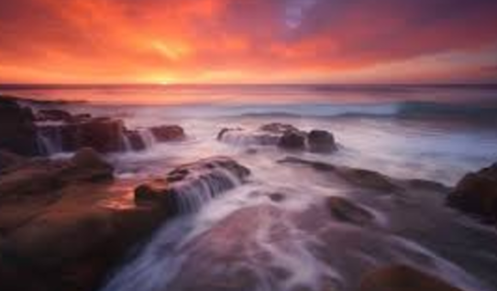

**REPRODUCTION OF GIVEN IMAGE:**

**Given prompt**: “a view of beach during the time of sunset and create a bridge pathway between one side to another”

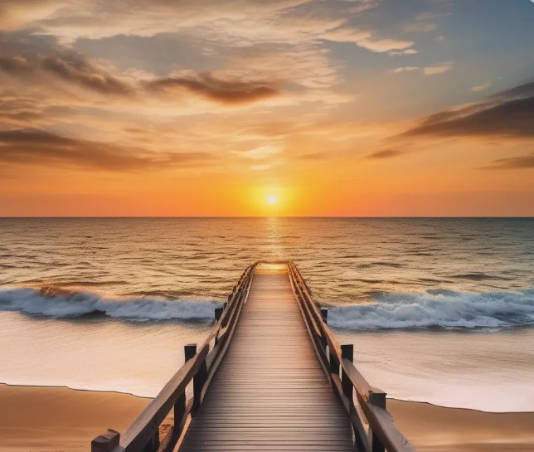

**ORIGINAL IMAGE 2:**

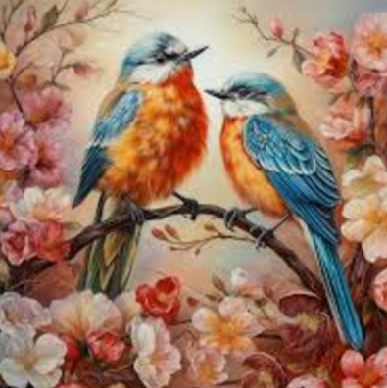

**REPRODUCTION OF GIVEN IMAGE:**

**Given prompt: “**The birds sitting on a branch of a tree surrounded by flowers and buds and one of the bird holding a bud/fruit in its beak”

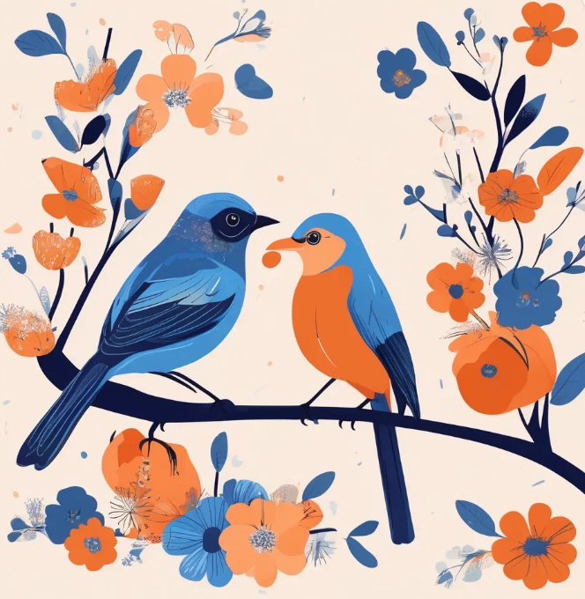

**Conclusion:**

By using detailed and well-crafted prompts, text-to-image generation models can be effective in reproducing an image closely. The quality of the generated image depends on how accurately the prompt describes the image's key elements. The experiment demonstrates the importance of prompt refinement and iteration when working with AI tools to achieve desired outcomes. With practice, the model can generate images